Please review the ‘Process’ pages of the Projects Toolkit (http://occweb/intranet/projects-toolkit/process) to ensure you are prepared for the requirements of Feasibility and Design stages including surveys, resource and CDM.
This template contains the criteria used for assessment, so each aspect should be covered in the information you provide.
Project name | Council Telephony Contracts Replacement
Author Name | Rocco Labellarte
Release | FULL | Version | 1.1 | Date | 14/10/2020

- Summary
The contracts for the provision of the BT One Phone system, with consolidated fixed line (unified communications) and mobile telephony (phone numbers, softphone users, SIMS, voice and data), signed on 1st April 2015, expire on 31st March 2020, with the option to extend for a year (subject to exemption approval). Given the age of the solution, going out to procure a replacement is recommended to leverage advances in technology and the reduction in cost of telecommunication services over the past five years.
We estimate savings of up to £100,000 per annum when compared to the current contracts, on the premise of the new contract(s) being less than the existing contract value of £460,000.
We require approval from CMT to proceed with the procurement exercise. This will require additional capital funding to coordinate the delivery. We anticipate this one off cost to be in the region of £50,000.
We have engaged with a specialist independent consultant and carried out a full technical and market options analysis. The findings from their report are summarised in the following options and recommended approach:
- Do nothing - Not Recommended – The market place should be tested against OCC’s functional requirements and to ensure value for money.

- Retender separately for Unified Communications and Mobile - Not Recommended – Unless To consider as offers the opportunity to review both marketplaces for “best of breed” for both technologies, but replicates the recommended option, with the additional overhead of duplicating the procurement effort.

- Use Microsoft Teams as a phone system - Not Recommended – Unless OCC have other reasons to consider E5 licensing this is likely to expensive and the integration with Netcall is high risk.

- Retender the contract (single procurement) in two lots (fixed line and mobile telephony) – recommended - with the option that it be a single or dual supplier solution.

- Recommendations
Describe which option is recommended and the reasons why. Describe, in summary, the capital and revenue costs of this work
The recommended option is that the Council retenders the contract (full procurement) in two lots for a single or dual supplier solution. This option offers the best value for money out of the four options and reduces both implementation and operational risks.
Soft market testing indicates the five-year running cost to be in the region of £1.25 million and £1.35 million, delivering a full-term saving of up to £100,000 per annum on the current contract, with up-to-date technology. In no situation with the cost of the full term license exceed the current annual expenditure of £1.8m.
We require approval from CMT to proceed with the procurement exercise. This will require additional capital funding to coordinate the delivery. We anticipate this one off cost to be in the region of £50,000.

- Outcomes

- With the existing five-year contract value being in the region of £1.8m, we estimate savings of up to £100,000 per annum with a new contract.
- Improved quality of service and more reliable 4G smartphone connections
- replacement for the Staff Telephone Directory and the Softphone service
- Better solutions and support for remote working, including potential integrations with Microsoft Teams.

- Approvals

The project will be managed by ICT. The client manager and CDM responsible will be Simon Park.

Board/Group | Name of Approver | Date
Development Board
Operational Delivery Group
CMT

- Corporate Priorities
Indicate which Corporate Priority this project aligns to and how
A vibrant and sustainable economy

Meeting Housing Needs

Strong and active communities

A clean and green Oxford

An efficient and effective Council

  - Improved quality of service for staff – replacement for the Staff Telephone Directory and the Softphone service
  - Lower running costs than the existing service
  - Improved Resilience
  - Better solutions and support for remote working, such as telephony integration with Microsoft Teams

- Options

Option 1 Summary

Do Nothing

- No disruption – nothing changes
- Several shortcomings have been identified in current system which mean the organisation is using outdated technologies which hinder agile and smart working practices
- Market trend is lower costs for technology, lower mobile costs (particularly data) and lower costs of digital telephone services. A tender process could drive down overall costs
- Lack of Software integration e.g. Microsoft Active Directory, Teams and CRM is increasing costs and causing operational challenges
- ISDN30 and Mitel support costs will increase

Costs
Will increase for integration elements
Risks and mitigations
Not Recommended –The market place should be tested against OCC’s functional requirements and to ensure value for money

Option 2 Summary

Retender through a single procurement (two lots) for a single or dual supplier solution
- Tender will test both cost and functionality
- Soft market testing for this report indicates that it would be most advantageous for cost
- Simplified account management (in the case of a single supplier)
- Tech fund established could be applied to both fixed line and mobile device purchases
- Single tender reduces procurement costs
- Some suppliers can offer choice of mobile networks to cover “not spots”
- Bidders from main telecommunications companies will be most attracted to the tender restricting options for innovative fixed line solutions
- However Lot 10 has most suppliers which could extend evaluation process
- Could be “compromise” fixed/mobile solution rather than best of breed for each
- Fixed Line will need evaluation focus on Quality whereas mobile will focus on Price
- Migration away from Legacy and unsupported systems

Costs
One-off capital cost £10,000 for project management, procurement.
One-off capital cost £40,000 for support and admin services during migration
Reduction in annual running costs of up to £100,000
Risks and mitigations
Recommended for Value for Money and Reducing Implementation Risks

Option 3 Summary

Retender separately for Fixed Line and Mobile

- Tender will test both cost and functionality
- Optimised, best of breed solution for each technology
- Will attract best technical fixed line solutions
- Will allow mobile to be evaluated with a high weighting on price (unsuitable for fixed line)
- Attract most appropriate bidders for each technology
- Implementation risks, particularly for number ports
- Tech fund restricted to purchase of mobile devices
- Increased procurement costs (compared with single tender, dual lots)
- Soft market testing for this report indicates that this option could be expensive as it would not optimally drive supplier discounts

Costs
One-off capital cost £4,000 for project management, procurement.
One-off capital cost £3,000 for support and admin services during migration
Likely increase in annual running costs of circa £10,000
Risks and mitigations
Introduces implementation risks with multiple suppliers and may be expensive

Option 4 Summary

Use Microsoft Teams as Phone System

- Embedded Microsoft product consistent with Office 365 technology stack
- Emerging product with a lot of Microsoft and third-party add-ons coming to market
- Provides a seamless fixed line solution with other Microsoft products for Presence, Audio and Video Conferencing, Online Meetings, Unified Messaging, etc.
- Opportunities to integrate with other partner organisations, e.g. call federation, shared calling services, etc.
- OCC will need to upgrade licenses to E5 at a significant monthly cost (typically uplift of £11-£12 per user per month)
- Unlikely to be straightforward to integrate with some applications e.g. CRM, Netcall
- Emerging product still has functionality gaps
- Would require mobile to be considered as a separate technology and tender
Costs
One-off capital cost £1,000 for project management, procurement.
One-off capital cost £4,000 for support and admin services during migration
Increase in annual running costs of circa £144k
Risks and mitigations
Not Recommended – Unless OCC have other reasons to consider E5 licensing this is likely to expensive and the integration with Netcall is high risk

Qualifying comments
For each of the statements below, please describe when the discussion took place and with whom and how it took place. There will need to be evidence of approvals
How have you ensured the recommended option is politically acceptable? - The proposal has been reviewed and approved by the Portfolio Member
What were the outcomes from discussions with Human resources? N/A
What were the outcomes from discussions with Financial Services? – Their recommendations have been incorporated into the paper.
What were the outcomes from discussions with Procurement? - Their recommendations have been incorporated into the paper.
What were the outcomes from discussions with ICT? - Their recommendations have been incorporated into the paper.
What were the outcomes from discussions with Diversity and Inclusion – As the procurement is for the provision of telephony services, there is no impact on staff or citizens.
What were the outcomes from discussions with Community Services regarding Community engagement? N/A
What were the outcomes from discussions with Environmental Sustainability? N/A
What were the outcomes of discussions with Property? N/A
What were the outcomes from discussions with Property Services? N/A
What were the outcomes from discussions with Planning? N/A
What were the outcomes of discussions with Building Control? N/A
What were the outcomes from discussions regarding CDM? N/A
What were the outcomes from discussions with Legal Services? Their recommendations have been incorporated into the paper.
What were the outcomes from discussions with Committee and Member Services on the decisions process? Their recommendations have been incorporated into the paper.
What were the outcomes from discussions with Corporate Governance regarding GDPR and a Privacy Impact Assessment (PIA)? As the procurement is for the provision of telephony services, there is no impact on staff or citizens.

- Resources
Describe the resource involved in the development and completion of this work. This section should also be used to describe the procurement approach to the resource required to deliver the project
Lead member¹ | Cllr. Mike Rowley
Director | Stephen Gabriel
Project Sponsor (Head of Service) ² | Helen Bishop
Programme Manager³ | Simon Park
Project Manager(s) | PTS Consulting
Stakeholder Manager⁴ | Rocco Labellarte
Business Analyst⁵ | PTS Consulting
Business Change Manager⁶ | Simon Park
Project Team (proposed) | PTS Consulting

- For projects wishing to seek capital funding, the Lead Member for the relevant business function MUST approve the business case
- The Head of Service MUST approve the business case before it will be considered by Review Panel
- Leads a defined set of interdependent projects and associated business change activities
- Identifies and analyses stakeholders and the planning of interactions and communications with them
- Understands the user and business requirements to ensure appropriate solutions are designed
- Prepares the user and business for the impact of the changes being delivered by the project

- Funding
Detailed funding for this work should be developed with your Financial Services Business Partner.

Financial information submitted by:
Finance Business Partner | Hannah Makins

- High Level Milestones
List the high level milestones and critical dates for the project.

Milestone | Target Date for completion
Approval of the recommendation, contract extension and funding | 11/12/2020
Procurement completed and new contract signed | 31/01/2022
Technical project initiated | 01/02/2022
New solution in place | 31/03/2022

- Next Steps
Please indicate the next steps in taking this work forward
- Presentation to the appropriate bodies for approval of the recommendation and approach, and funding to deliver the project.

- IMPORTANT Appendices
Additional documentation should be attached as appendices. These documents include (but not limited to):
- Full, detailed project plan for the next stage of work
- Full, detailed communications plan for the next stage of work
- Privacy Impact Assessment

Project Assessment Criteria
[For Review Panel use only]

This page forms the basis for the assessment of projects at the Business Case stage.
The document will become the audit record for the recommendations of the ‘Review Panel’.

Business Case
Project name | Council Telephony Contracts Replacement
Author Name | Rocco Labellarte
Owner Name | Rocco Labellarte
Release | FULL | Version | 1.1 | Date | 14/10/2020

Recommendation
Do not progress
Add to pipeline as a future project
Progress to delivery
Summary of costs and funding source (for projects going ahead – extract from finance information

1 | Is this project part of the Council’s core business? | NO
 | If it is not Core business, why is this proposal being put forward and which of the Council’s Corporate priorities is it linked to?
2 | Is the project required to maintain existing infrastructure in terms of security and functionality | YES
3 | Are there interdependencies with other, approved projects/initiatives? | NO
 | Which Projects:
4 | What are the benefits of this project (describe the benefits for each option below):
 | Income generation | NO
 | Efficiencies in provision of service | YES
 | Environmental impacts | N/A
 | Are any Capital receipts being achieved | NO
 | What is the Community benefit | Better quality service generally
5 | What is the estimated cost of the Project | Check one box
 | Less than £10,000
 | £10,001 – £499,999 | X
 | More than £500,000
6 | How will the project be funded?  Capital funding is required, to be approved by Finance.
7 | Is there a Health & Safety or ICT security issue that this project is resolving? NO

Financial Assessment section

Deliverability Analysis
Project rating: 1-3 based on the criteria in the first column.

Criteria | Easy (1) | Medium (2) | Hard (3)
Attitudes and Behaviours | The behaviours of staff (at all levels) will support project delivery. | The behaviours of staff (at all levels) are inconsistent and present a risk to this project | To deliver the project, new attitudes and behaviours are required
Timeframes and resources | The project can be delivered as part of business as usual and can be done relatively quickly. | The project will occur in the medium term and will require an internal project team to be set up | The change will require additional skills to be brought into the business. The project will occur in the medium to long term.
Roles and responsibilities | The project can be implemented with no impact on current roles. | To implement the project, roles will need to be modified. | To implement the project, new roles will need to be created.
System | Current system functionality support the project or are not relevant | Current systems can be configured to support the change. | Current systems need to be modified to support the change.
Processes | The project will have little or no impact on existing processes and will be localised to the process area. | The project will require processes to be redesigned and may cross over to a number of functions | The project will require new processes to be designed.
Political interface | There is no member engagement required at this stage  Members are engaged with this project and know about the different steps we need to take to progress it | Members are aware of this project and generally supportive of it | Members are actively promoting this project and engaging with residents despite a lack of clarity around its viability or feasibility

DECISIONS DELEGATED TO OFFICERS

Complete this form to record details of all decisions made by officers acting under delegated powers. Send the completed form to forwardplan@oxford.gov.uk

Decision title: | [Add the name of the project and delete the options that do not apply]  Name of project /  - Approval of grant application >£10k  - Award of feasibility funding and to proceed to Feasibility stage >£10k  - Approval to proceed to Design stage  - Approval to award a contract  - Approval to proceed to Delivery  Please refer to the Officer Decisions page on the intranet for further information regarding which officer/s is able to take a decision
Decision date: | [Day Month Year]
Source of delegation: State how the decision was delegated. Was it an express delegation made at a meeting of Council / Cabinet or a general delegation under the Council’s Constitution? Please provide details.
What decision was made? Explain briefly – include financial details of any income or expenditure relating directly to this decision. Please indicate whether information is exempt / confidential.
Reasons for making the decision
Other options considered: List any alternatives that were available to the decision taker and why they were rejected
Documents considered: Please attach any new documents relevant to the decision | [List the documents accompanying this decision]
Key or Not Key: (see notes overleaf):
Wards affected: | [See ward map]
Declared conflict of interest: By any Cabinet member consulted over decision.
This form was completed by:  Name & title:  Signature:  Date: | [Name / title]  [Must be a formal signature]  [Day Month Year]
Law & Governance approval:  Name & title:  Signature:  Date: | [Name / title]  [Must be a formal signature]  [Day Month Year]
Financial Services approval:  Name & title:  Signature:  Date: | [Name / title]  [Must be a formal signature]  [Day Month Year]
Decision taken by:  Name & title:  Signature:  Date: | [Name / title]  [Must be a formal signature]  [Day Month Year]

Officer Decisions - Notes
The law requires the Council to record executive and non-executive decisions taken by officers under delegated powers and to publish them on the Council’s website.
These requirements apply to decisions that would have been taken by Council or Cabinet if delegated powers had not been given to an officer:
- under a specific delegation granted at a meeting of Council or Cabinet
- under a general delegation (where responsibility is delegated in the Constitution) and the effect of the decision is to:
  - grant a permission or licence;
  - affect the rights of an individual;
  - award a contract or incur expenditure with a value in excess of £10,000;
  - award a contract with a value in excess of £10,000 but less than £500,000;
  - acquire or dispose of freeholds or leaseholds with a consideration or premium in excess of £10,000 but less than £500,000;
  - grant to new tenants or dispose of leases with a rental value in excess of £10,000 but less than £125,000 (this excludes assignments, holding over and rent reviews);
  - grant ‘project approval’ for projects in excess of £10,000 but less than £500,000;
  - make a regulatory order which affects a number of people, for example a Public Space Protection Order or a Parking Place Order;

These requirements do not apply to:
- planning and licencing matters where there are established arrangements for recording decisions: or
- decisions which are purely administrative or operational in nature

Officers making such decisions must complete a written statement containing details of the decision taken. A copy of this decision notice must be retained by the relevant service for at least 6 years and any background papers for 4 years.
Exempt or Confidential information
Information relating to a delegated officer decision does not have to be made public if it is exempt or confidential. Summary information from this decision sheet (excluding all exempt or confidential information) will be published on the Council’s website.
Please highlight any text which is exempt or confidential and you do not wish for it to be published to the Council’s website
Key or Non Key Decision
A key decision is an executive decision likely to have a significant effect on people living or working in at least two wards; or to involve spending or saving £500,000 or more.
A key decision can only be taken and recorded here if notice of it has been published in the Forward Plan for at least 28 clear days.
Ward Map

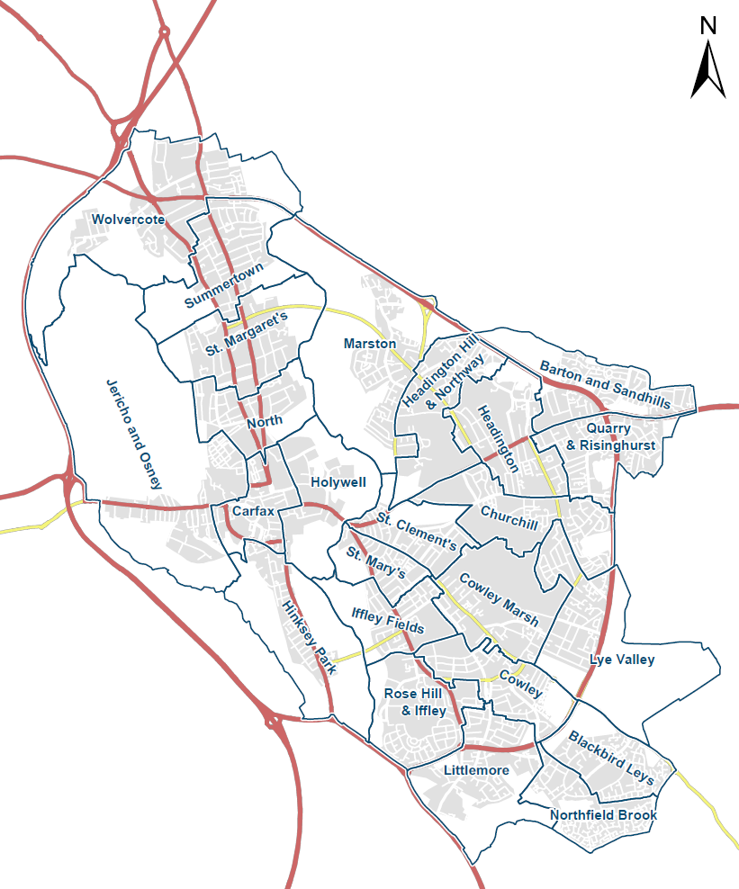

the Local Authorities (Executive Arrangements) (Meetings and Access to Information) (England) Regulations 2012/2089 (Regulation 13(4)) and The Openness of Local Government Bodies Regulations 2014/2095 (Regulation 7)

